**I、MCU part**

**Power supply : Micro USB or 3.7V Li-ion**

**Debugging tools : IDE(MDK5&STM32F1XX Package) \ Jlink \ four or five DuPont lines**

**（Development board hardware design fixed SWD debug mode, you can not use the serial port to download.）**

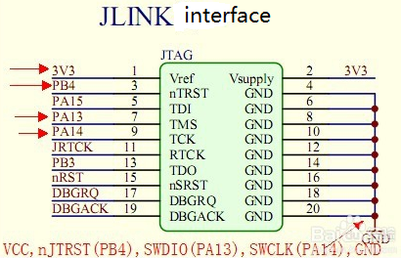**How to connect?**

**JLink and BPI NB-IoT Linaro SWD mode connection:**

|  |  |
| --- | --- |
| **J-link** | **BPI NB-IoT Linaro SWD** |
| **3V3 (Pin1)** | **VCC** |
| **GND (Pin4.6.8.10……)** | **GND** |
| **SWDIO (Pin7)** | **DIO** |
| **SWCLK (Pin9)** | **CLK** |
| **nJTRST （Pin3）Can not connect** | **RST Can not connect** |

**MDK5 “Options for Target” — “Debug” setting：**

**First need to build the project file based on the corresponding chip, and in the Options of Target do the following settings**

**（Project file specific settings include but are not limited to the following settings）**

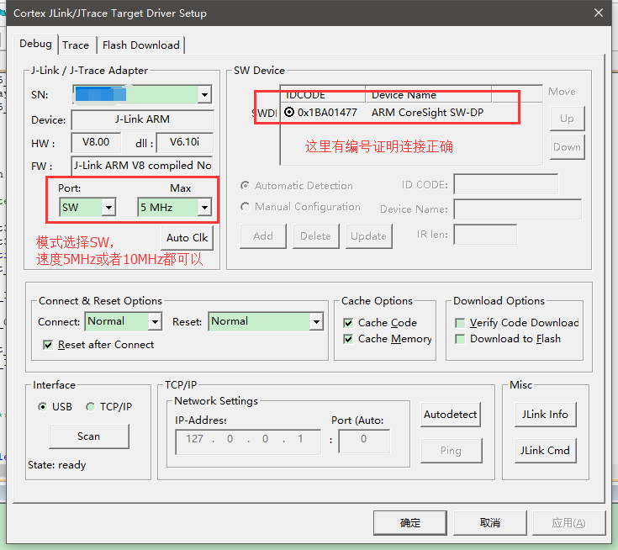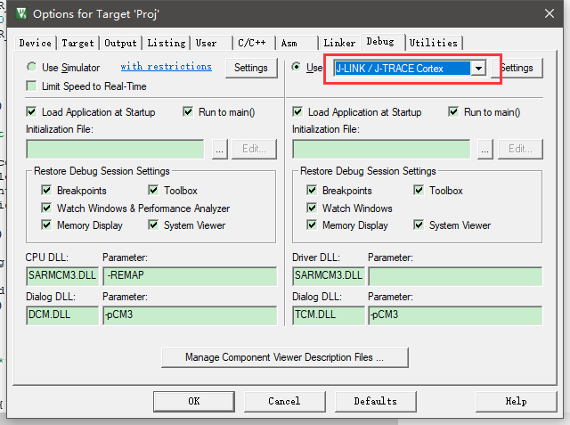

**（Development board needs to be kept powered）**

**Debug method：**

1. **You can use the debug serial port (MCU USART1) to debug.**
2. **Use Micro USB virtual serial port for debugging.**

**The above two methods require MCU program support**

**Note：**

1. **Debug serial port, SWD simulation interface spacing 2.54mm, GPIO pitch 2.0mm**
2. **2. The LED next to the Micro USB is the power indicator, which should be on after any power-up.**

**II、NB-Iot part**

**This module needs to be used with NB_IOT SIM card.**

**Different carriers support different frequency bands，Module operating frequency band to distinguish the module model，such as：**

|  |  |  |
| --- | --- | --- |
| **carrier** | **module model** | **frequency band** |
| **China Mobile** | **BC95-B8** | **900MHz** |
| **China Unicom** | **BC95-B20** | **800MHz** |
| **China Telecom** | **BC95-B5** | **850MHz** |

**Firmware version：**

**Query firmware instructions：AT+CGMR**

**Result：V100R100C10B656SP2 firmware version is B656SP2**

**Scramble code function：**

**The module is consistent with the base station.**

**SIM Card:**

**The module can used two kinds of SIM card. Standard SIM card or eSIM card.**

**Antenna:**

**The module has reserved the MHF WiFi antenna interface, which can be selected according to the actual usage of the product.**